**SQL PROJECTS**

1. have  created database kg_insurance_company

CREATE DATABASE kg_insurance_company;

USE kg_insurance_company;

CREATE TABLE customers (

    customer_id INT PRIMARY KEY,

    full_name VARCHAR(100),

    gender CHAR(1),

    age INT,

    region VARCHAR(50)

);

CREATE TABLE policies (

    policy_id VARCHAR(10) PRIMARY KEY,

    customer_id INT,

    policy_type VARCHAR(50),

    start_date DATE,

    end_date DATE,

    premium DECIMAL(10, 2),

    FOREIGN KEY (customer_id) REFERENCES customers(customer_id)

);

CREATE TABLE claims (

    claim_id VARCHAR(10) PRIMARY KEY,

    policy_id VARCHAR(10),

    claim_date DATE,

    claim_amount DECIMAL(10, 2),

    claim_type VARCHAR(50),

    status VARCHAR(50),

    FOREIGN KEY (policy_id) REFERENCES policies(policy_id)

);

CREATE TABLE agents (

    agent_id VARCHAR(10) PRIMARY KEY,

    agent_name VARCHAR(100),

    region VARCHAR(50),

    total_clients INT

);

3. Inserted records into the TABLE

customers records

DELIMITER //

CREATE PROCEDURE insert_customers()

BEGIN

    DECLARE i INT DEFAULT 1;

    WHILE i <= 1000 DO

        INSERT INTO customers (customer_id, full_name, gender, age, region)

        VALUES

        (i,

        CONCAT('Customer ', i),

        IF(MOD(i, 2) = 0, 'M', 'F'),

        FLOOR(18 + (RAND() * 50)),

        CASE

            WHEN MOD(i, 4) = 0 THEN 'Gauteng'

            WHEN MOD(i, 4) = 1 THEN 'KZN'

            WHEN MOD(i, 4) = 2 THEN 'Western Cape'

            ELSE 'Eastern Cape'

        END);

        SET i = i + 1;

    END WHILE;

END//

DELIMITER ;

CALL insert_customers();

policies records

DELIMITER //

CREATE PROCEDURE insert_policies()

BEGIN

    DECLARE i INT DEFAULT 1;

    WHILE i <= 1000 DO

        INSERT INTO policies (policy_id, customer_id, policy_type, start_date, end_date, premium)

        VALUES

        (CONCAT('P', LPAD(i, 3, '0')),

        i,

        CASE

            WHEN MOD(i, 3) = 0 THEN 'Home'

            WHEN MOD(i, 3) = 1 THEN 'Auto'

            ELSE 'Life'

        END,

        DATE_ADD('2022-01-01', INTERVAL i DAY),

        DATE_ADD('2023-01-01', INTERVAL i DAY),

        ROUND(300 + (RAND() * 700), 2));

        SET i = i + 1;

    END WHILE;

END//

DELIMITER ;

CALL insert_policies();

claims table records

DELIMITER //

CREATE PROCEDURE insert_claims()

BEGIN

    DECLARE i INT DEFAULT 1;

    DECLARE policy_count INT;

    DECLARE random_policy_id VARCHAR(10);

    SELECT COUNT(*) INTO policy_count FROM policies;

    WHILE i <= 200 DO

        SET random_policy_id = CONCAT('P', LPAD(FLOOR(RAND() * policy_count) + 1, 3, '0'));

        INSERT INTO claims (claim_id, policy_id, claim_date, claim_amount, claim_type, status)

        VALUES

        (UUID(),

        random_policy_id,

        DATE_ADD('2022-01-01', INTERVAL FLOOR(RAND() * 365) DAY),

        ROUND(1000 + (RAND() * 10000), 2),

        CASE

            WHEN MOD(i, 3) = 0 THEN 'Accident'

            WHEN MOD(i, 3) = 1 THEN 'Death'

            ELSE 'Fire'

        END,

        CASE

            WHEN MOD(i, 2) = 0 THEN 'Approved'

            ELSE 'Rejected'

        END);

        SET i = i + 1;

    END WHILE;

END//

DELIMITER ;

Agents records

DELIMITER //

CREATE PROCEDURE insert_agents()

BEGIN

    DECLARE i INT DEFAULT 1;

    WHILE i <= 1000 DO

        INSERT INTO agents (agent_id, agent_name, region, total_clients)

        VALUES

        (CONCAT('A', LPAD(i, 3, '0')),

        CONCAT('Agent ', i),

        CASE

            WHEN MOD(i, 3) = 0 THEN 'Gauteng'

            WHEN MOD(i, 3) = 1 THEN 'KZN'

            ELSE 'Western Cape'

        END,

        FLOOR(20 + (RAND() * 80)));

        SET i = i + 1;

    END WHILE;

END//

DELIMITER ;

CALL insert_agents();

🔹 Query 1: Count of Customers per Region

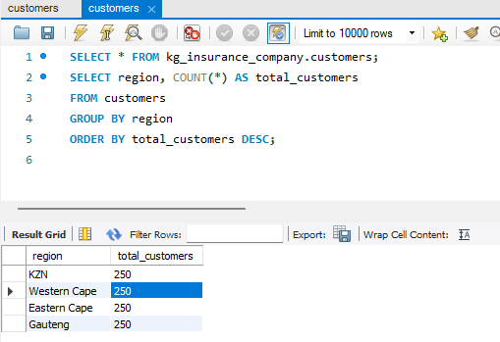

🔹 Query 2: Average Premium per Policy Type

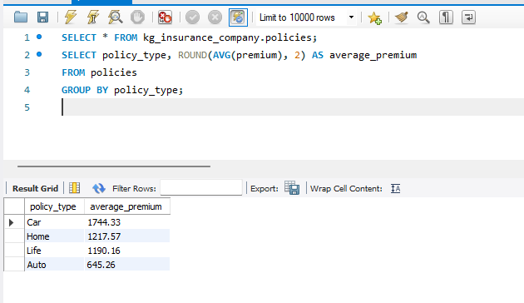

🔹 Query 3: Gender Distribution of Customers

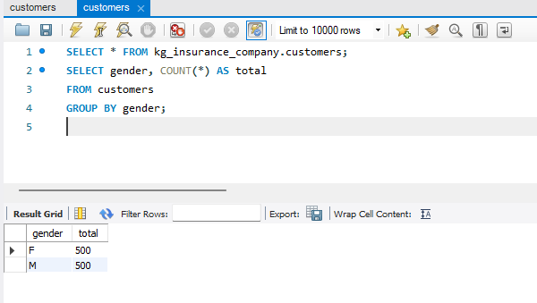

🔹 Query 4: Claims by Status

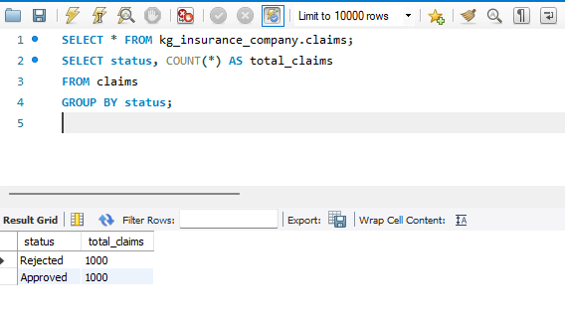

🔹 Query 5: Total Claims Amount by Region

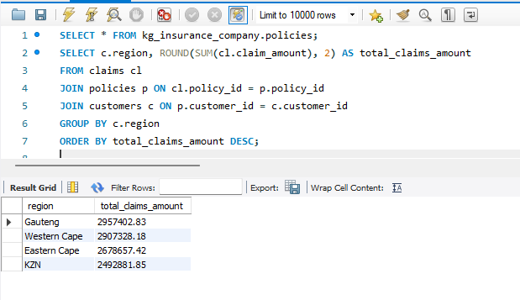

🔹 Query 6: Top 10 Highest Claim Amounts

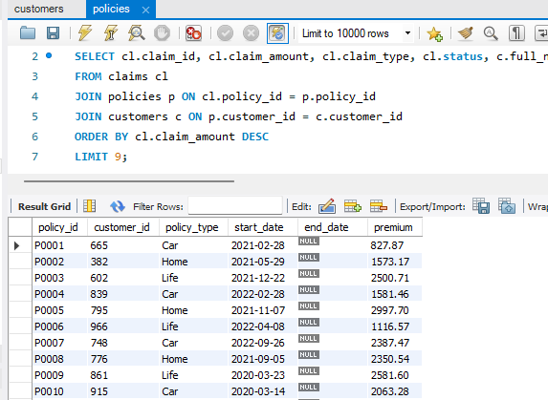

🔹 Query 7: Policies Without Claims

🔹 Query 7: Policies Without Claims

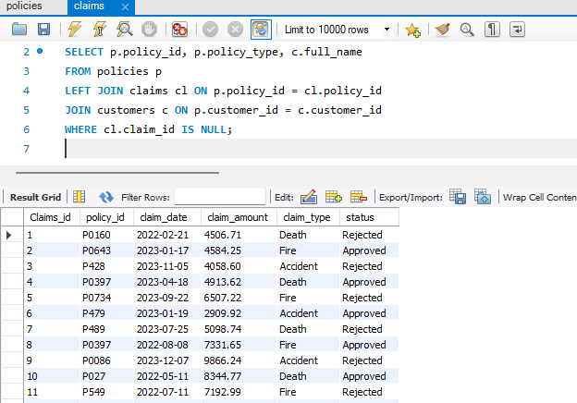

🔹 Query 8: Categorize Customers by Age Group

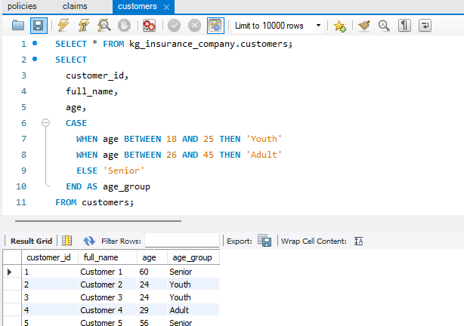

🔹 Query 9: Agent Load Summary by Region

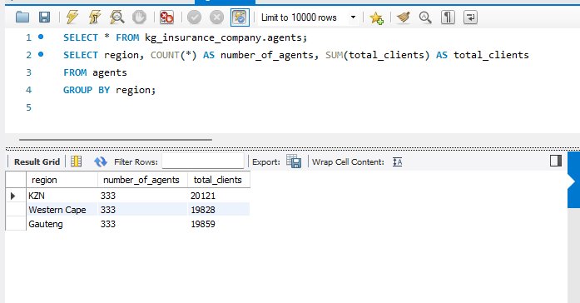

🔹 Query 10: Customers with More Than 1 Claim

